MODULEASSESMENT CO3 AT2

HARSHAVARDHAN R 192412308

QUESTION 24
AIM:

To develop an energy monitoring communication model that continuously measures electrical energy consumption in public infrastructure (street lights, water pumps, government buildings, bus stations, etc.) and transmits the data to a central monitoring station for analysis, control, and energy optimization.

OBJECTIVES:-

- To monitor real-time energy consumption of public infrastructure.
- To establish a reliable communication network for data transmission.
- To detect abnormal energy usage and power losses.
- To optimize energy utilization through data analysis.
- To provide remote monitoring and control facilities.
- To reduce operational costs and improve sustainability.

CODE:-

%EnergyMonitoringCommunicationModel
%ForPublicInfrastructure

clc; clear; closeall;

%Numberofinfrastructurenodes n = 5;

%Simulatedenergyconsumption(kWh) energy = [120 135 150 170 160];

%Thresholdforabnormalusage threshold = 155;

%Nodenames

nodes=
{'StreetLight','WaterPump','TrafficSignal','BusStation','PublicBuilding '};

disp('ENERGYMONITORINGCOMMUNICATIONMODEL');
disp(' ');

%Communicationtocentralmonitoringstation for i = 1:n
fprintf('Node:%s\\n',nodes{i});
fprintf('EnergyUsage:%.2fkWh\\n',energy(i));

%Checkforabnormalenergyusage if energy(i) > threshold
fprintf('Status:ALERT-HighEnergyConsumption\\n'); else
fprintf('Status:NORMAL\\n'); end

fprintf('DatatransmittedtoCentralMonitoringStation\\n\\n'); end

%Totalenergyconsumption totalEnergy = sum(energy);
fprintf('TotalEnergyConsumed=%.2fkWh\\n',totalEnergy);

%Plotenergyconsumption figure;
bar(energy); set(gca,'XTickLabel',nodes); xlabel('Public Infrastructure Nodes'); ylabel('EnergyConsumption(kWh)');
title('EnergyMonitoringCommunicationModel'); grid on;

% Simulated communication delay disp('Simulatingcommunicationnetwork...'); for t = 1:5
pause(0.5);
fprintf('Transmittingpacket%d...\\n',t); end

disp('Allenergydatasuccessfullyreceivedatthecontrolcenter.');

FORMULA:

Electrical Power
Power consumed by a device:
P=V×I
Where:
- P = Power (Watts)
- V = Voltage (Volts)
- I = Current (Amperes)

Energy Consumption
E=P×t
Where:
- E = Energy (Wh or kWh)
- P = Power (W)
- t = Time (hours)

Communication Efficiency
η=Transmitted DataReceived Data​×100
Where:
- η = Communication Efficiency (%)

OUTPUT:-

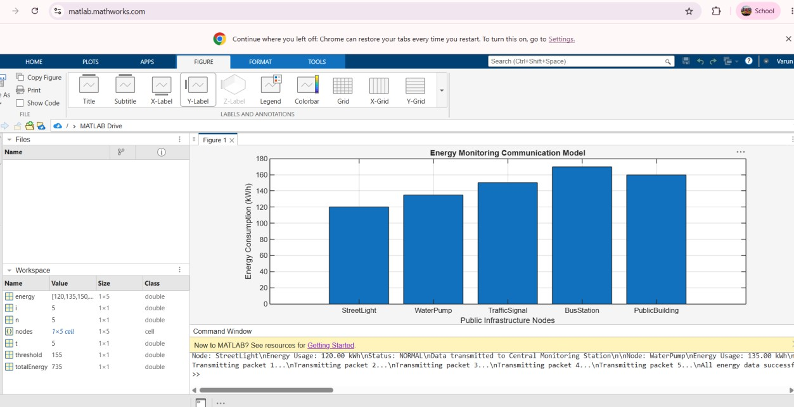

CONCLUSION :-

The proposed Energy Monitoring Communication Model enables efficient collection and transmission of energy data from public infrastructure. The system helps authorities monitor energy usage, reduce wastage, improve operational efficiency, and support sustainable smart-city development through real-time communication and data analytics.

Expected Result
- Successful real-time monitoring of energy consumption.
- Accurate communication of energy data to a central server/cloud.
- Identification of energy wastage and faulty equipment.
- Reduction in overall power consumption by 10–30%.
- Improved energy efficiency and operational reliability.
- Better decision-making for public infrastructure management.

